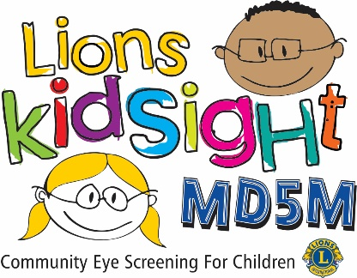**MD5M Lions KidSight**

**Screening Follow Up Report**

|  |  |
| --- | --- |
| District |  |
| Club |  |
| Lion |  |

|  |  |  |  |  |
| --- | --- | --- | --- | --- |
| Date | Screening Site | Type | # Kids Present | # Kids Screened |
|  |  |  |  |  |

Type: PRS = Pre-School, HS = Head Start, HF = Health Fair, CE = Community Event  
Please include the complete name and address of the screening site

|  |  |  |  |
| --- | --- | --- | --- |
| Age | Sex | Indicator | Result |
|  |  |  |  |
|  |  |  |  |
|  |  |  |  |
|  |  |  |  |
|  |  |  |  |
|  |  |  |  |
|  |  |  |  |
|  |  |  |  |
|  |  |  |  |
|  |  |  |  |
|  |  |  |  |
|  |  |  |  |
|  |  |  |  |
|  |  |  |  |
|  |  |  |  |
|  |  |  |  |

**Age** **& Sex** = from consent form

**Indicator** = condition(s) the system indicates as the cause of the referral

**Result** = did the child go to the doctor and what was the result of the visit  
**Result,** **No Response** = 3 or more attempts made to contact the parent without success  
Use additional forms if necessary