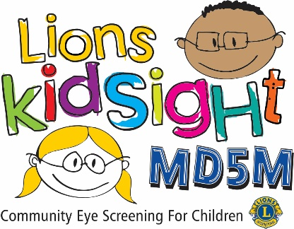**MD5M Lions KidSight**

**Indicator Site Report**

|  |  |
| --- | --- |
| District | Click or tap here to enter text. |
| Club | Click or tap here to enter text. |
| Lion | Click or tap here to enter text. |

|  |  |  |  |  |
| --- | --- | --- | --- | --- |
| Date | Screening Site | Type | # Kids Present | # Kids Screened |
| Click or tap here to enter text. | Click or tap here to enter text. | Click or tap here to enter text. | Click or tap here to enter text. | Click or tap here to enter text. |

Type: PRS = Pre-School, HS = Head Start, HF = Health Fair, CE = Community Event  
Please include the complete name and address of the screening site

|  |  |  |  |  |  |  |  |  |  |  |
| --- | --- | --- | --- | --- | --- | --- | --- | --- | --- | --- |
| Indicator |  | Age | | | | | | |  |  |
| 0 – 6 Months | 6 – 11 Months | 1 Year | 2 Years | 3 Years | 4 Years | 5 Years | 6 Years | Other | Total |
| Myopia |  |  |  |  |  |  |  |  |  |  |
| Hyperopia |  |  |  |  |  |  |  |  |  |  |
| Anisometropia |  |  |  |  |  |  |  |  |  |  |
| Anisocoria |  |  |  |  |  |  |  |  |  |  |
| Gaze Asymmetry |  |  |  |  |  |  |  |  |  |  |
| Astigmatism |  |  |  |  |  |  |  |  |  |  |

Please indicate in the age column the number of children referred with the specific indicator obtained from the refer report from your vision screener.Click or tap here to enter text.