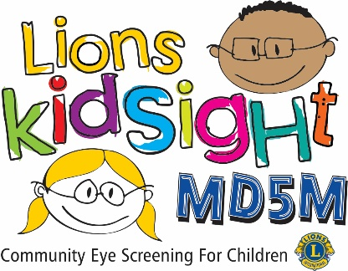
MD5M Lions KidSight
Results of Vision Screening

Dear Parent,
Your child _______________________________________ was screened for possible vision problems by trained volunteers from the <<< --- Click to enter Club Name --- >>> Lions Club.
The screening today indicates that your child’s vision is not within normal range for his or her age or the Measurement was Incomplete or Inconclusive and the box is checked below. Incomplete or Inconclusive measurements rarely happen, but it can occur for a number of eye related reasons, thus we highly recommend you have your child checked by an eye care professional.
While this screening is not diagnostic, it did suggest that your child should be further examined by an eye care professional such as an optometrist (O.D.) or ophthalmologist (M.D.).
The Lions Club conducting the screening may contact you within 2-3 weeks to determine if you were able to make an appointment with an eye care professional or if you need assistance.
If you do not have an Eye Care Provider you may want to check with your Primary Care Provider and/or your Health Insurance Provider for a referral or you can use the following resources:
- For an Optometrist: https://www.infantsee.org/find-a-doctor
- For an Ophthalmologist: https://doctor.webmd.com/providers/specialty/ophthalmology/minnesota.
Select Pediatric Ophthalmology in the dropdown section.
Lions Clubs and other organizations such as the American Academy of Pediatrics recommend vision screenings and professional eye examinations as part of regular health examinations for children.
If you have any questions about this screening, please feel free to contact <<< --- Click to enter Name & Contact Info for your District Chair --- >>>
Sincerely,
<<< --- Click here to enter your name --- >>>
☐ Measurement Incomplete or Inconclusive

Note: The results of the screening may be attached or printed on the back of this form. We suggest that you present this information to the eye care professional at the time of the exam.

REFER

