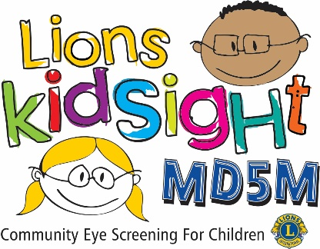
MD5M Lions KidSight

Dear <<< --- Click to enter Director’s Title --- >>>,
The <<< --- Click to enter Club Name --- >>> Lions Club wishes to inform you that it has the capability of performing pediatric eye screenings of pre-school children, ages six-months old through 6 years. Screenings are also available for school age children.
Members of our Lions Club have been trained in the use of the <<< --- Choose Screener --- >>> Vision Screener and are available to perform screenings at your location at any time.
The vision screener we use is capable of screening for Myopia (near-sightedness), Hyperopia (far-sightedness) and Anisocoria (pupil size deviations). In addition, Astigmatism (blurred vision), Anisometropia (unequal refractive power), and Strabismus (eye misalignment) which can result in Amblyopia (lazy-eye). The individual screening takes just a few seconds and is performed from a distance of about three feet. There is no physical contact with the child and no eye drops are administered. We will provide a print-out of the results for each child who should receive follow up care from an eye care professional which is given to you for forwarding to the parent. We provide parent consent forms and cover letters for you to send to the parents prior to the screening date.
It is important to understand that this is only a screening and does not constitute an examination or diagnosis of vision problems.
This service is offered free of charge by the local Lions Club under the MD5M Lions KidSight vision screening program. I will be contacting you to discuss how and when we can provide this vital service.
If you have any questions I can be reached at <<< --- Click to enter your contact information --- >>>

Sincerely Yours,
<<< --- Click here to enter your name --- >>>

